Activation and deactivation of Dealer Management system
SCOPE
Activation and deactivation of Dealer Management system.
This procedure applies to NSC Dealers:
We activate and deactivate the dealer once got approval from INCADEA Support team with NSC DMS/WMS Team heads approval.

RESPONSIBILITIES
Level 2 and Level 3 Engineers

Step 1: Login to Server check database inventory and check the dealers reside on which
Database server.
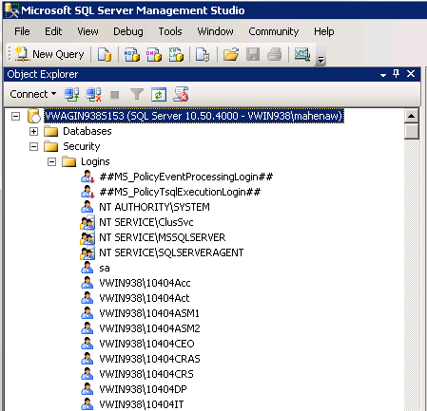

Step 2: Go to security tab expand the folder and go to Logins filter and insert correct Dealer
Name with KVPS number correctly
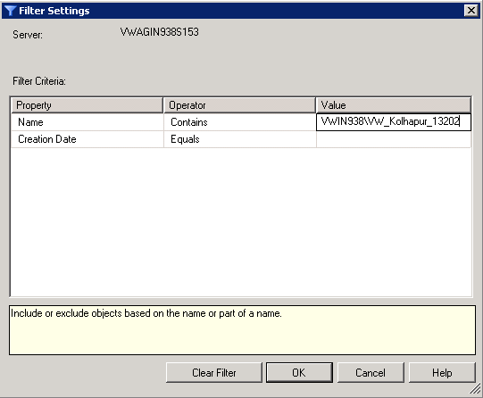
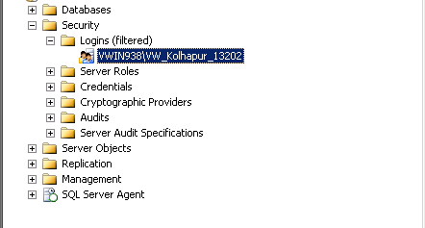

Step 3: Right click to the dealer properties then go to user mapping and revoke the logins
Access provided to the user.
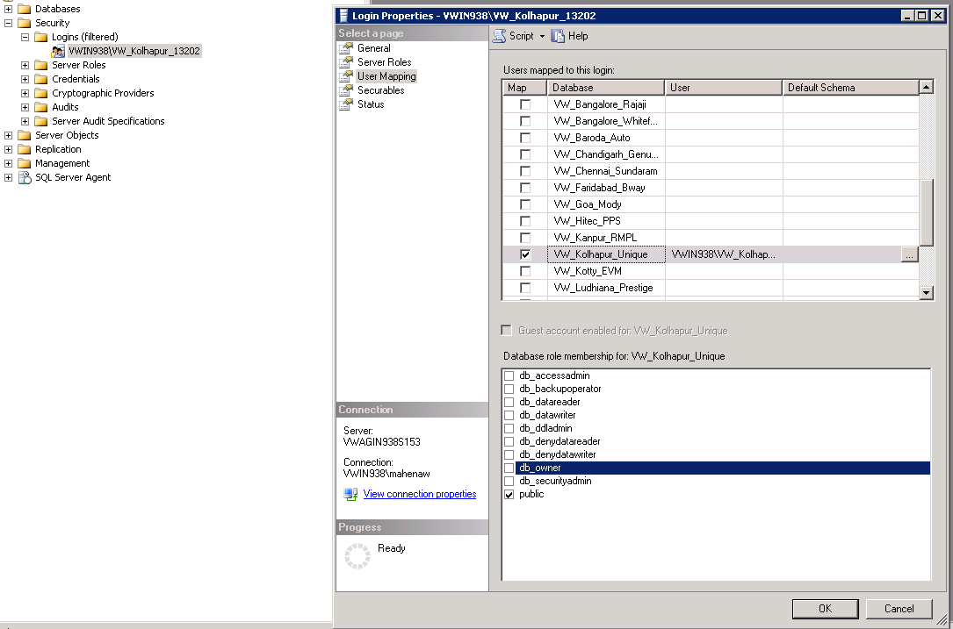

Step 1: Once got confirmation from incadea and DMS/WMS team we have to activate
The dealer by creating Dealer with KVPS number.

Step 2: Check whether the Windows NT Id is created by windows team or not.
This can be checked through filter setting in login properties.

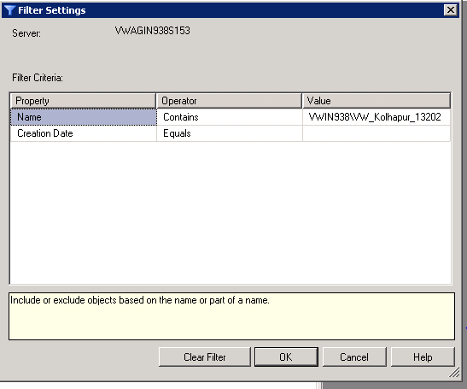

Step 3: Provide necessary access as per the approval from the DMS /WMS process owner

